Bear Unit Self-Assessment
Green: I met this learning target and understand the learning.
Yellow: I met some of the learning target and I am still developing my learning.
Red: I am not yet meeting the learning target and still need to develop my learning.

Criteria How I felt about my work
I listened for important information and recorded this idea on my poster.
I wrote down my information in a complete sentence. I used a capital letter at the beginning of the sentence, a finger space between words, and a period at the end.
I drew 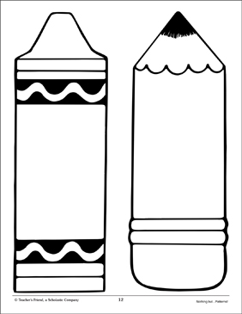 my pictures with details, used colours that make sense, and filled in the space.

