*******’s STAR Behaviour Safe, Teachable, Accountable, Respectful
Date: ___________________________
Before Recess After Recess After Lunch

Goals: 1. I can raise my hand before I speak or stand.
2. I can remember to breathe deeply and stay positive.
Don’t forget to ask for a break if you need it!
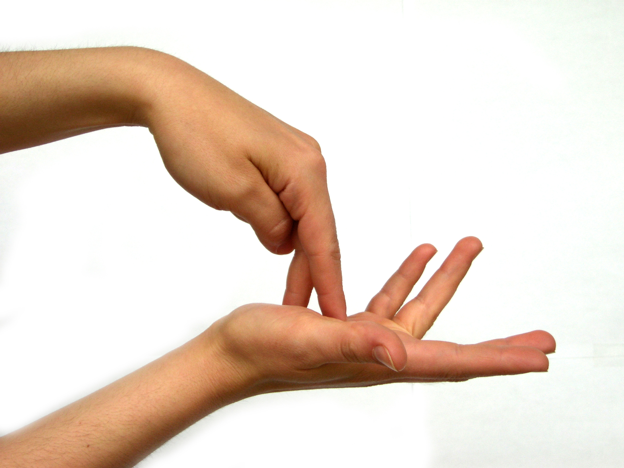
Incentives:
- 8 stars = 1 special sticker or a STAR ticket
- 9 stars = 2 special stickers, 2 STAR tickets, or 10 minutes on laptop the next morning

Consequences:
- Tucker will receive 1 warning for each of the goals before marking with an X.
- If he continues the behaviour, he will have to sit at his table for the duration of the lesson

